Who is the most senior employee base on level?
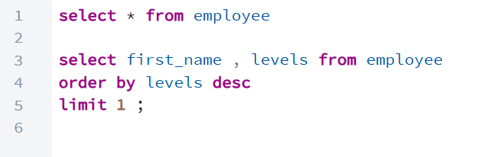

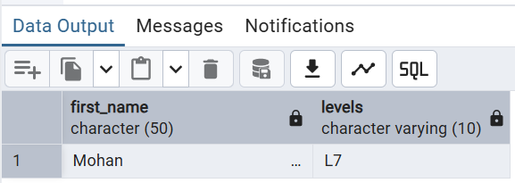

Which country has most invoices ?

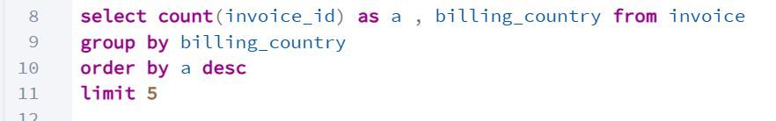

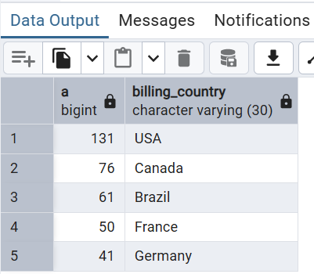

What are top 3 values of total invoices ?

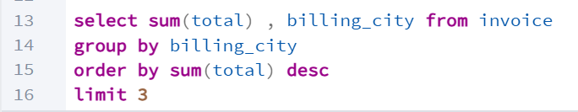

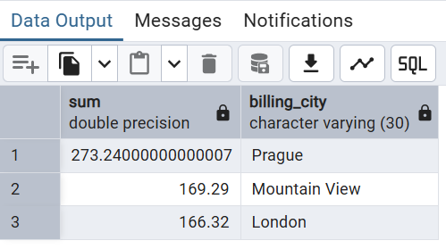

Which city has the best customer ? we want to held ha show in one city that has highest sum of
return both the city name and sum of all invoices .

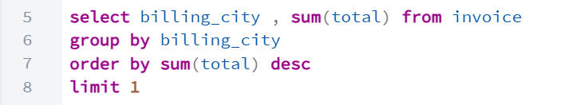

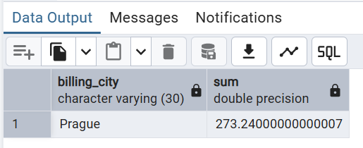

Who is the best customer ? that who spend more money.

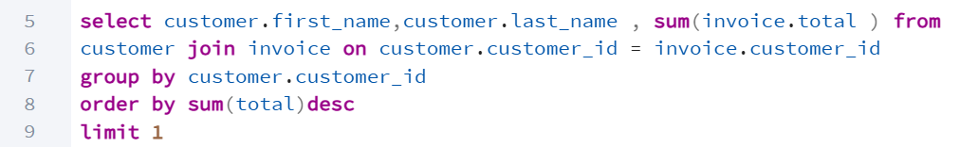
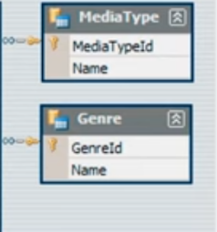
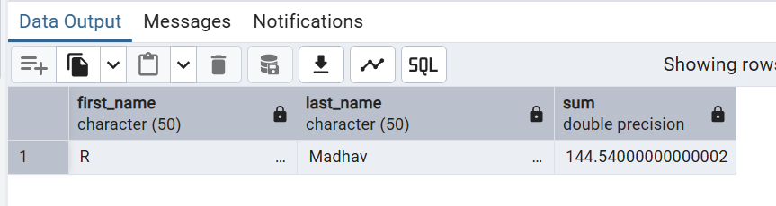

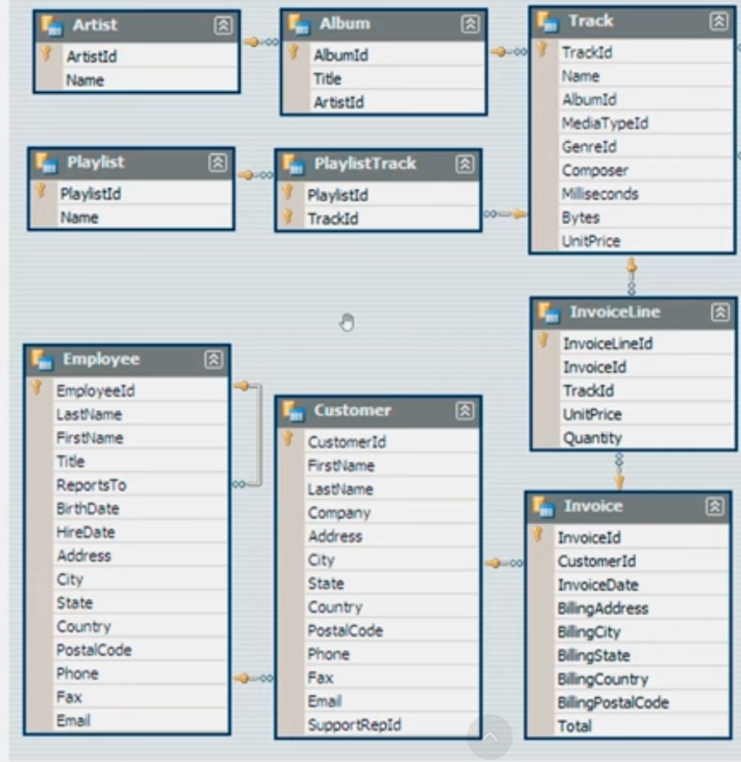

Write query to return the email , first name , last name , and genre of all music listener . return your list by alphabetic order by email .

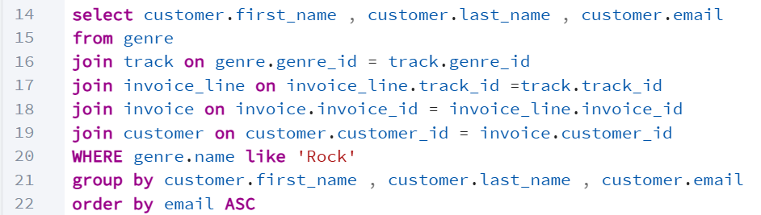
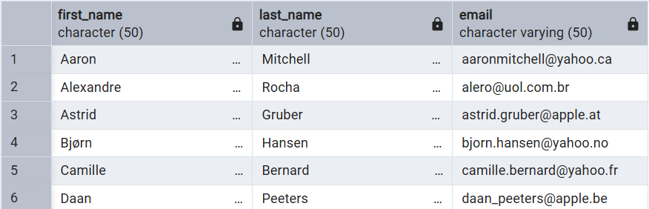

Lets invite the artist who sing more songs in the ROCK band and return there name and artist_id?

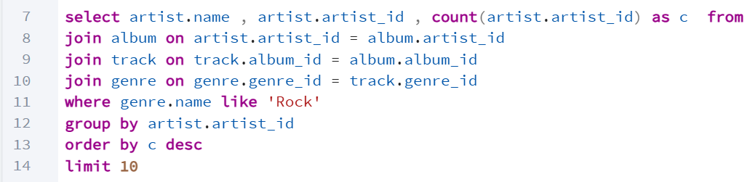

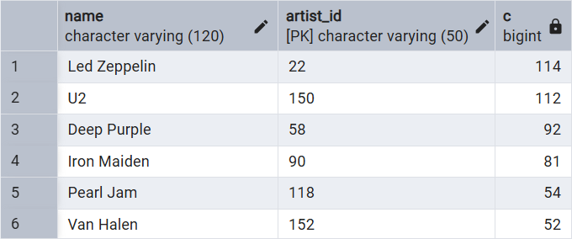

Return all track name that has length is more than average length of the song return the name and millisecond for each track . order by the song length with the longest song list first.

